**Report on**

**UNIVERSITY PREDICTION**

Submitted by:

TEAM-2

Juveriya

Milkuri Anusha

**ACKNOWLEDGEMENT**

The Task of completion of the project requires co-operation of several Individuals.we are grateful to our mentors Mr.Rammohan Bethi for the kind support and guidance in completing our project.

we thank SMARTBRIDGE for providing this platform to explore

Thanking You

Yours Sincerely,

Team 2

Juveriya

Milkuri Anusha

TABLE OF CONTENTS

1. INTRODUCTION

1.1 Overview

1.2Purpose

2. LITERACY SURVEY

2.1 Existing Problem

2.2 Proposed Problem

3. THEORITICAL ANALYSIS

3.1Block Diagram

3.2Hardware/Software Designing

4. EXPERIMENTAL INVESTIGATIONS

5. FLOWCHART

6. RESULT

7. ADVANTAGES&DISADVANTAGES

8. APPLICATIONS

9. CONCLUSION

10. FUTURE SCOPE

11. BIBILOGRAPH

APPENDIX

A.Source code

**1)INTRODUCTION**

* 1. **OVERVIEW:**

Machine learning is the study of computer algorithms that improve automatically through experience. It is seen as a subset of artificial intelligence. Univeristy prediction has been a high interest research area, as it requires noticeable effort and knowledge of the field expert. Here, we used Multiple Regression which is a supervised Machine Learning Technique to predict the Chance of Admit in a University . Supervised Machine Learning is used to learn a model from labelled training data that allows us to make predictions about unseen or future data. **Multiple Regression** is an [ensemble learning](https://en.wikipedia.org/wiki/Ensemble_learning) method for [regression](https://en.wikipedia.org/wiki/Regression_analysis) and other tasks that operate by constructing training time and outputting the class .

**1.2 PURPOSE:**

The ease of making better choices and making better decisions in terms of selecting colleges is our aim. Our analysis on colleges for the students makes easier for them to make accurate decision about their preferred Universities. For such analysis, it requires future possibilities from the past record data from DTE which can potentially make the predictions and recommendation for students. Our analysis with the data mining methods would help giving probable accuracy and this requires analytical methods for predicting future recommendation. Today, most students make mistakes in their preference list due to lack of knowledge, improper and incorrect analysis of Universities and insecure predictions. Hence repent and regret after allotment. Our project will solve the general issue of the student community by using technology.

**2.)LITERATURE SURVEY:**

**2.1 Existing Problem:**

Every student facing dificulty to find the university which is suitable to them based on their grade ,and other information. Our analysis on Universities for the students makes easier for them to make accurate decision about their preferred Universities.

2.2 Proposed Solution:

Using the Machine Learning algorithms we can predict the chance of Admit in a University . We have to take the massive dataset and apply various regression algorithms to effectively predict the Chance of Admit. The algorithm with the best accuracy is taken as solution then it will be integrated to wed based application where the user’s can access

3.)THEORITICAL ANALYSIS:

3.1 Block Diagram:

Deployment

Data Modelling

Data preprocessing

Data

3.2 Software/Hardware Designing:

Software:

1.anaconda:

Jupyter notebook

2.Python web frameworks

Hardware:

1.Laptop

4.**) EXPERIMENTAL INVESTIGATIONS:**

In experimental research we found the required parameters to predict the chance of Admit by removing duplicate columns and primary keys which do not effect the output. By plotting scatter plots and Boxplots we got to know where the outliers are present and removed for better accuracy.so by data visualization we understood that there is no linear relation between dependent and independent variables so we choose decision tree and random forest algorithms to train the model. On calculating the r2_score we finally got to know that using Multiple Regression we used to predict Chance of Admit in better way

5.FLOW CHART:

Data

Data

Training Data

Testing Data

Multiple Regession

Evaluation

Model

**6.)RESULT:**

Flask Web Application

Predicted

value

After Training and Testing model with Regression Algorithms we got good accuracy with Multiple Regression so we choose this model for University Prediction .We predict chance of Admit based on model of the Grade, LOR,SOP, Rating, Research and GRE

**7.)ADVANTAGES &DISADVANTAGES:**

Advantages:

1. Manual work is less
2. No Human intervention needed(automation)
3. Prediction accuracy is good
4. Student can easily able to know their chance of admit in a university
5. It helps student for making decision for choosing a right college.
6. Here the chance of occurrence of error is less when compared with the existing system.
7. Avoids data redundancy and inconsistency.
8. It is fast, efficient and reliable.

Disadvantages:

1. Large Data Needed
2. Technical Failures
3. Training model becomes hectic due to large data

**8.)Applications:**

In this 5th generation world, University prediction System plays a vital role:

* Students like to predict which college has the highest chance to admit before taking the admissions.
* It helps student in choosing the best college.

9.)CONCLUSION:

The main goal of this work is to create a Machine Learning model which could be used by students who want to pursue their education in the Universities. Many machine learning algorithms were utilized for this research. Multiple Regression model compared to other ones. Students can use the model to assess their chances of getting admission into a particular university with an average accuracy of 73 percent. A GUI was developed to make the program, from a non-technical perspective, usable and user-friendly. Using node-red the user interface was developed. The ultimate goal of research will be accomplished successfully, as the system allows students to save the lot of time and money that they would spend on educational mentors and application fees for Universities where they have less chances of getting admissions.

10)FUTURE SCOPE:

As the technology is growing rapidly, No one is willing to go somewhere to know the chance of getting the aspired college. They can use this System from anywhere and anytime to know their chance of getting their aspired college.

11.)BIBILIOGRAPHY:

Data Collection (Online): <https://www.kaggle.com/meghraj09/admission-prediction-comparing-algorithms/data>

Model Building: <https://thesmartbridge.com/documents/spsaimldocs/Machinelearning.pdf>

Source Code:

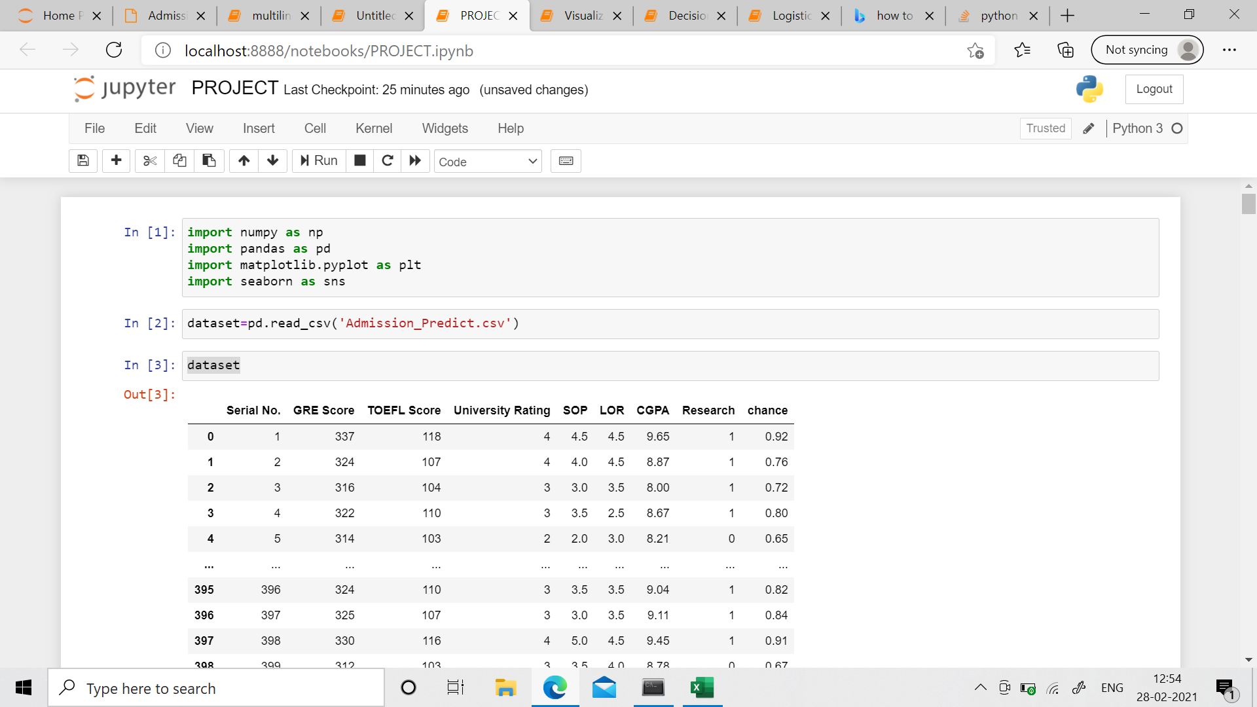Importing libraries:

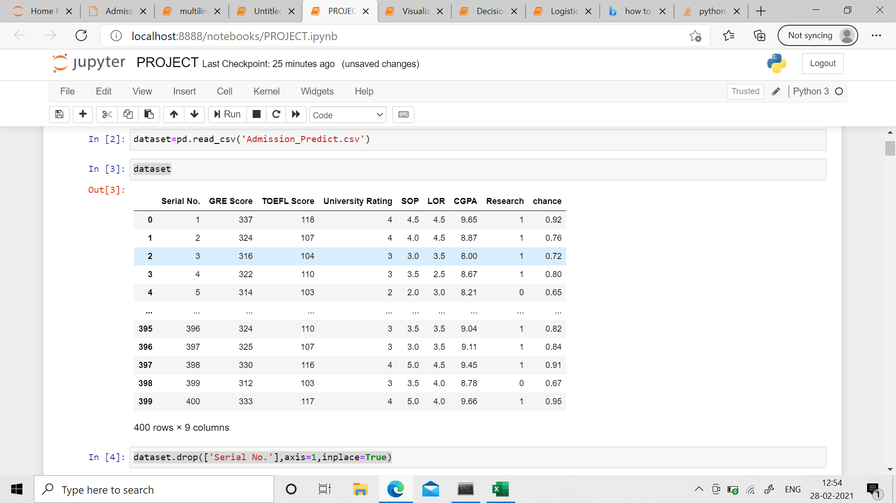Importing Dataset:

Taking care of missing Values:

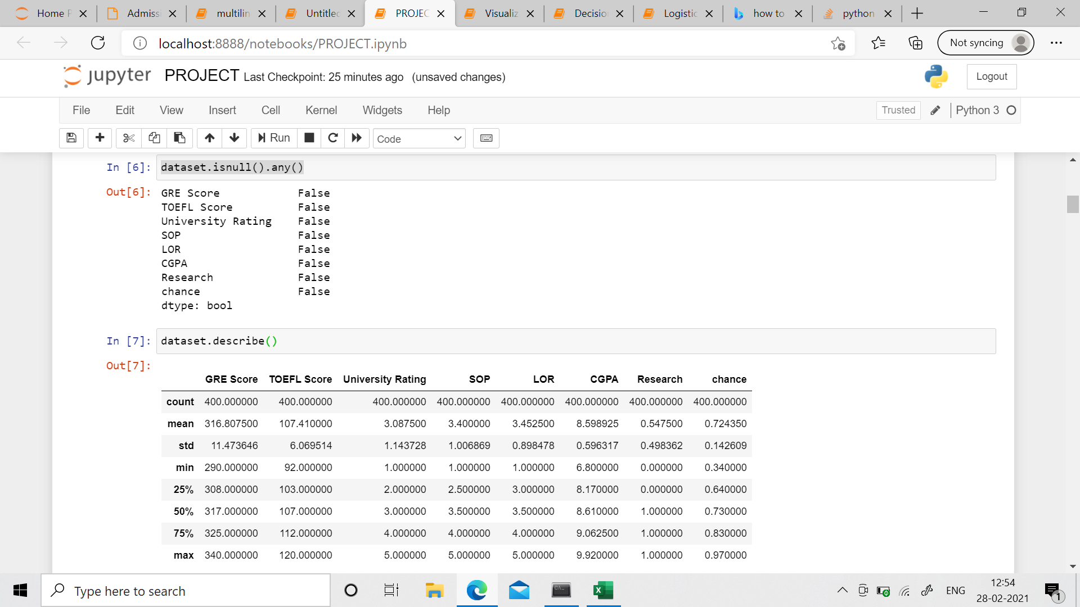

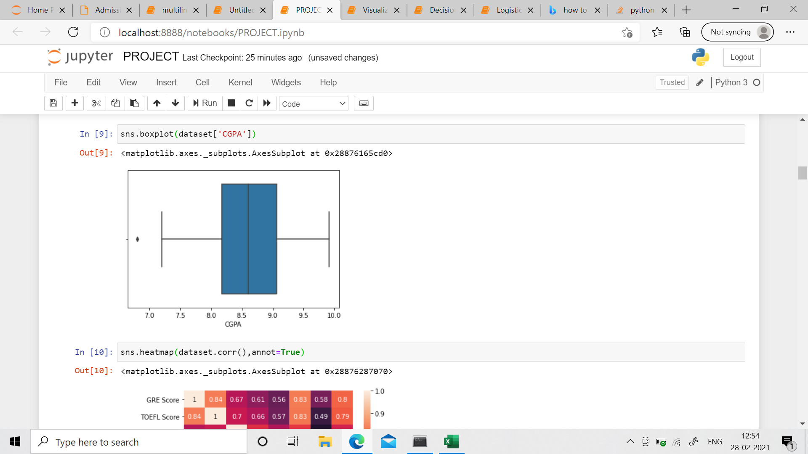 Data Visualisation:

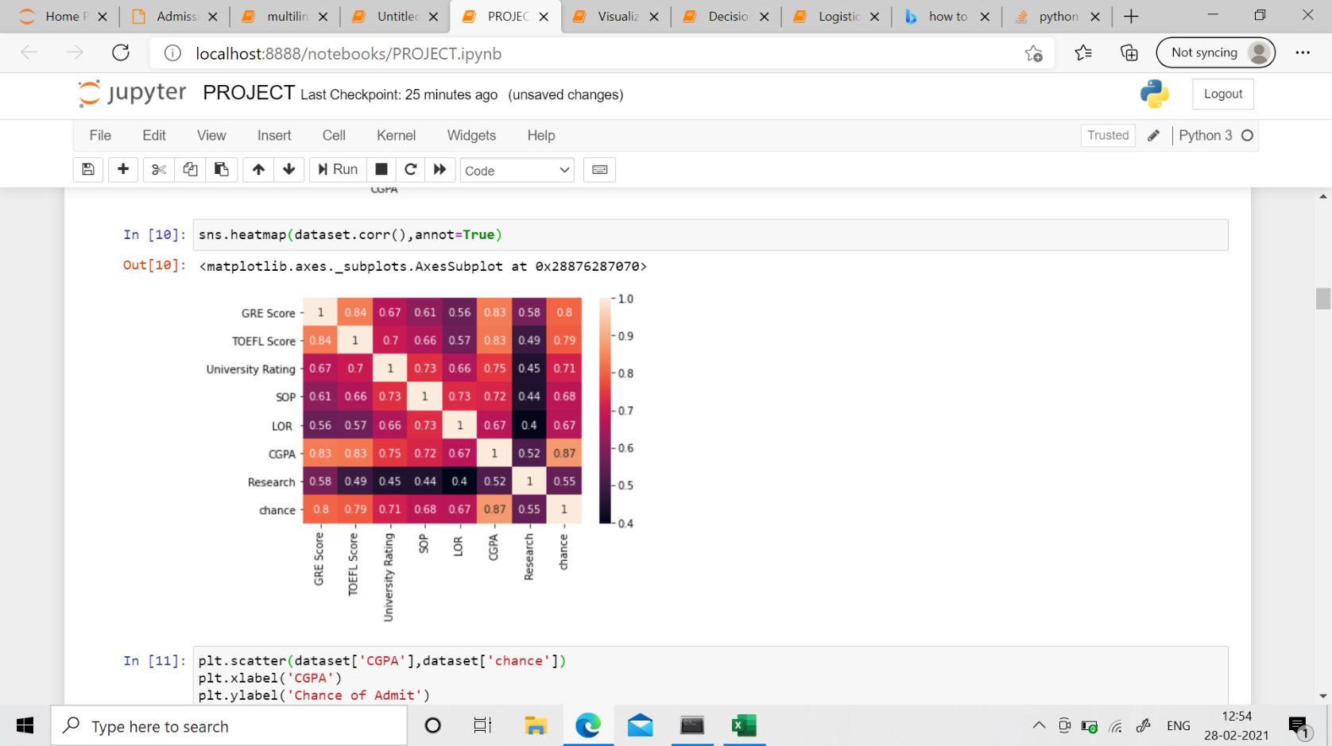

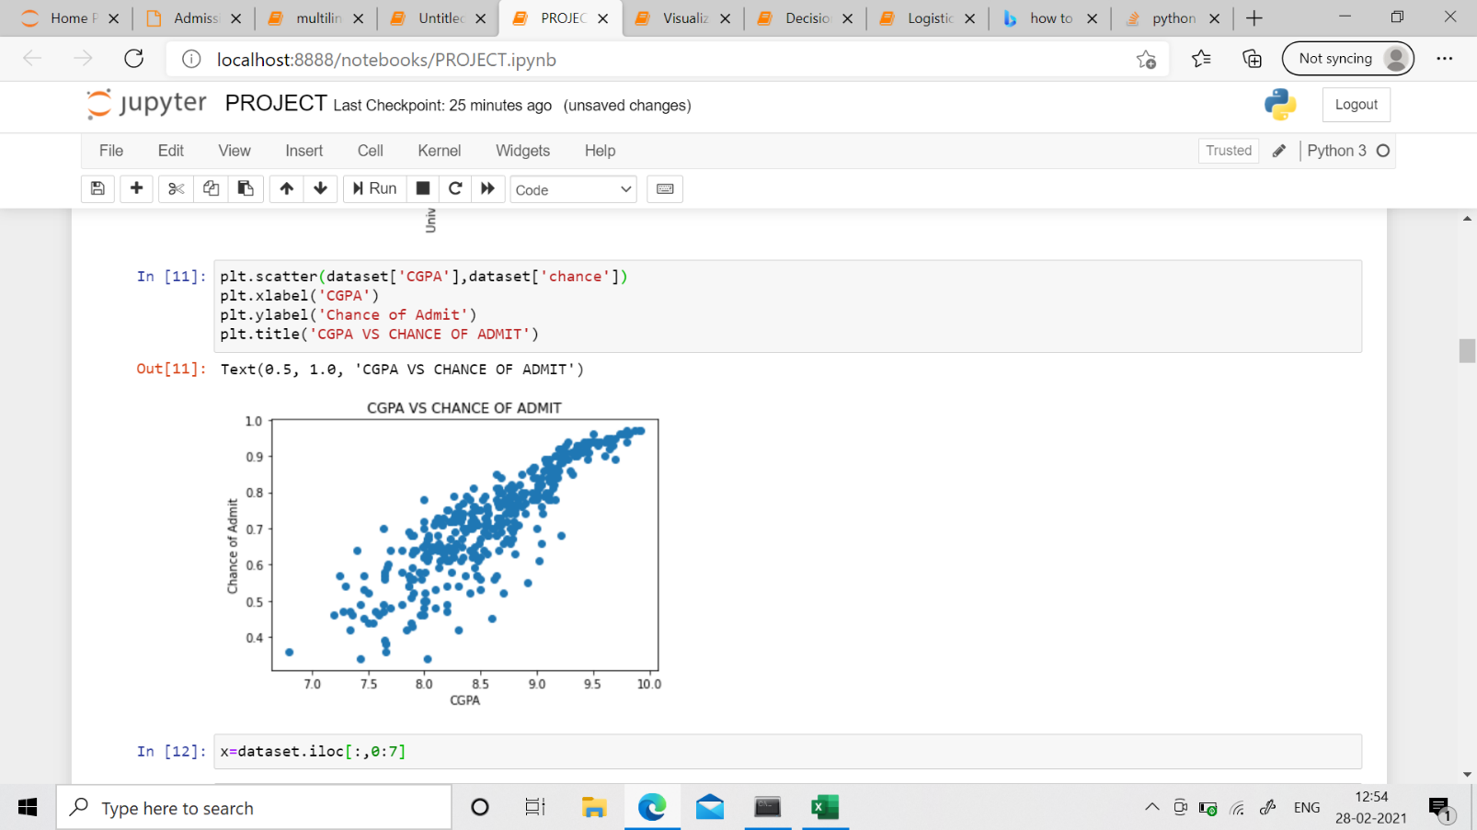

Splitting data into training and testing test:

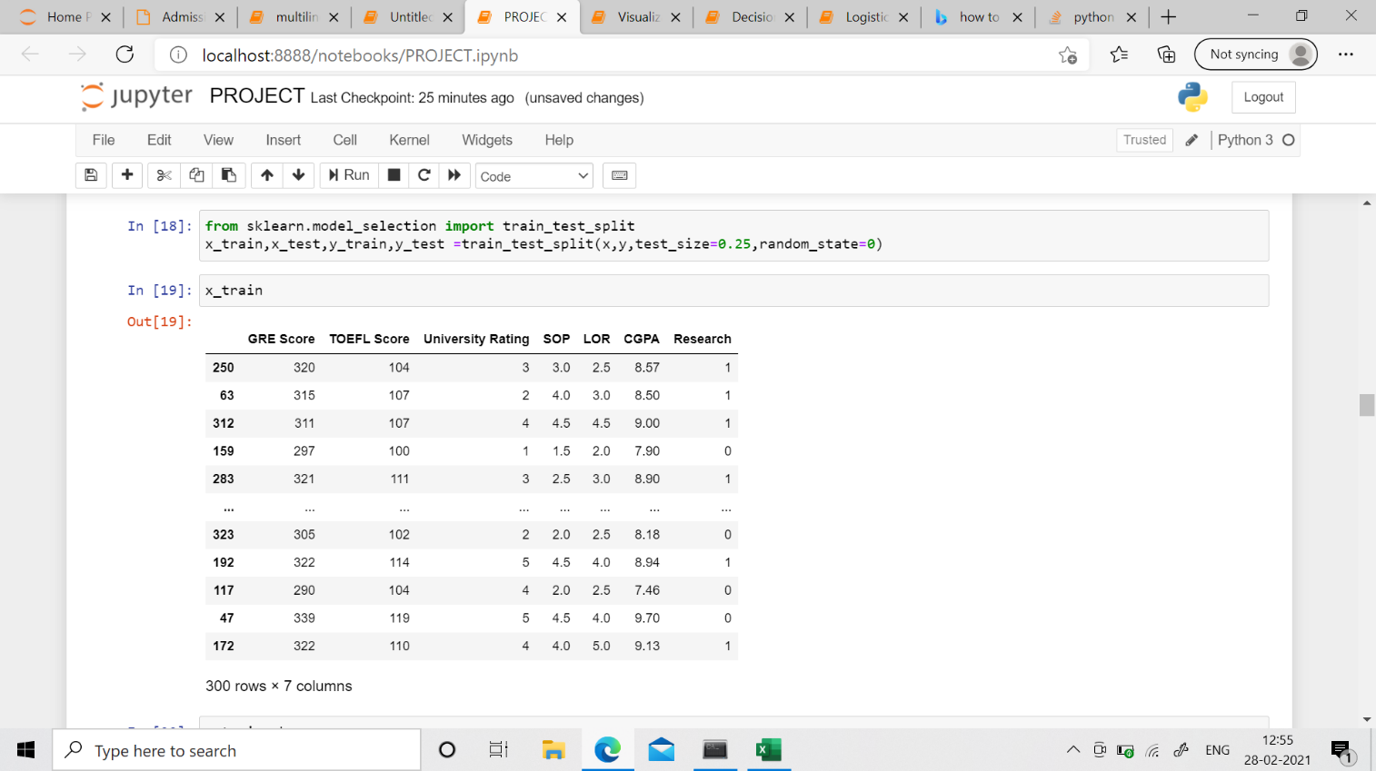

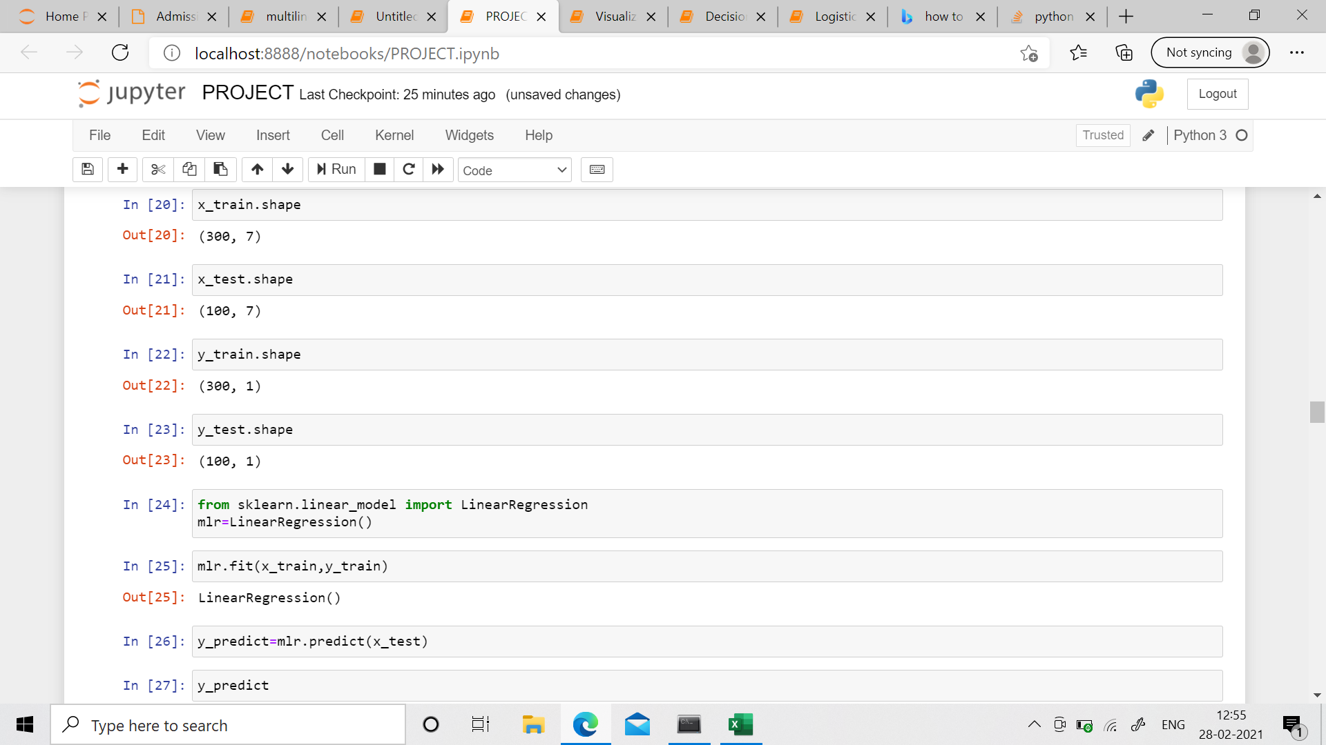

Model Building:

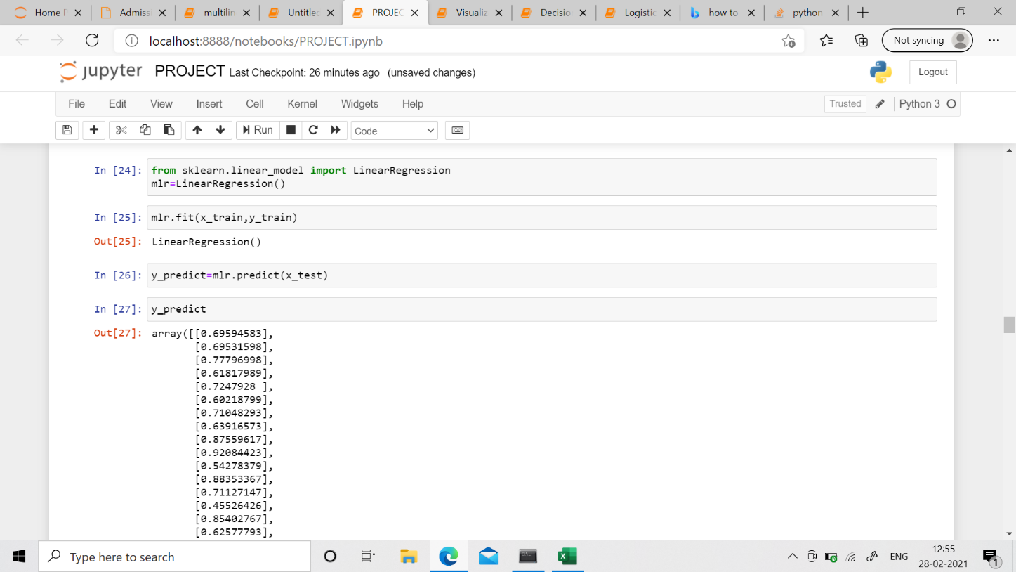

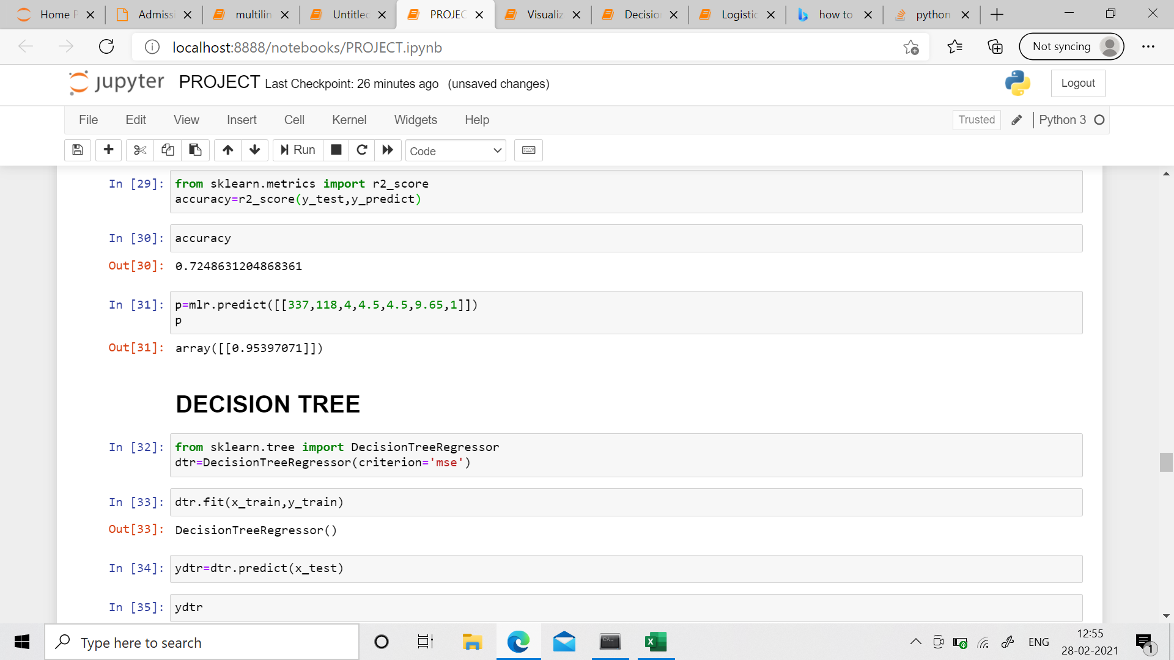Evaluation: